CSA0501-DATABASE MANAGEMENT SYSTEMS
LAB EXPERIMENTS DATE: 16/07/2026

EXPERIMENT 5 -- SELECT with WHERE Clause and Pattern Matching

AIM:

To view records from the Flight Reservation System tables using SELECT statements with WHERE clause and pattern matching (LIKE).

PROCEDURE:

1. Open MySQL Workbench and select the Flight_Reservation database.
2. Ensure Passenger, Flight and Booking tables contain sample records.
3. Execute SELECT statements using the WHERE clause.
4. Execute SELECT statements using the LIKE operator with wildcard characters.
5. Verify the retrieved records after each query.

PROGRAM:

1. Display Passenger ID, Passenger Name and Age of all passengers
SELECT Passenger_ID, Passenger_Name, Age
FROM Passenger;

OUTPUT:
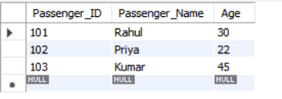
2. Display all female passengers
SELECT * FROM Passenger
WHERE Gender='F';

OUTPUT:
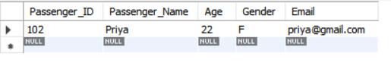

- Display passengers booked for Flight_ID = 201

SELECT * FROM Booking
WHERE Flight_ID=201;

OUTPUT:
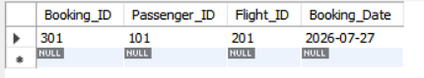

4. Display flight details from Chennai
SELECT * FROM Flight
WHERE Source='Chennai';
OUTPUT:
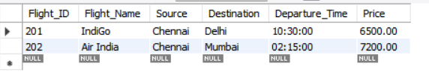

5. Display flights whose destination is not Delhi
SELECT * FROM Flight
WHERE Destination<>'Delhi';
OUTPUT:
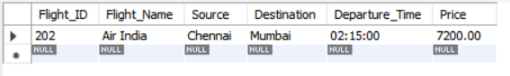

6. Display passengers whose names end with 'ul'
SELECT * FROM Passenger
WHERE Passenger_Name LIKE '%ul';

OUTPUT:
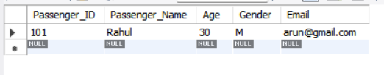

7. Display passengers whose names contain 'ar'
SELECT * FROM Passenger
WHERE Passenger_Name LIKE '%ar%';
OUTPUT:
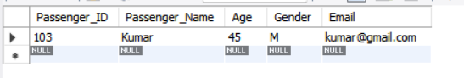

8. Display passengers whose email contains 'gmail'
SELECT * FROM Passenger
WHERE Email LIKE '%gmail%';
OUTPUT:
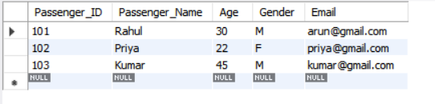

9. Display passengers whose names do not contain six letters
SELECT * FROM Passenger
WHERE Passenger_Name NOT LIKE '______';
OUTPUT:
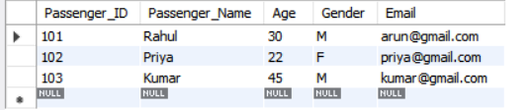

10. Display passengers whose names contain 'am'
SELECT * FROM Passenger
WHERE Passenger_Name LIKE '%am%';
OUTPUT:
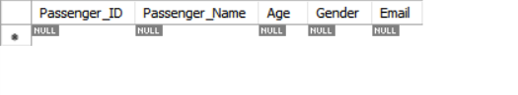

RESULT:

Thus, the records from the Flight Reservation System tables were successfully displayed using SELECT statements with WHERE clause and pattern matching.

